Contents
A 5
AC Equipment 5
AC Filter 5
AC Station Control 6
AC Yard 6
Auxiliary Equipment and 132kV Power 7
B 8
Back Metering 8
Bipolar DC Transmission 8
Bipole Protection 8
BOT 8
BOOT 8
Bridge Rectifier 9
Bridge Inverter 9
C 10
CAN 10
CCC 10
CET 10
CCME 10
CHINCA 10
Common Cathode Group 10
Common Anode Group 10
Commutation Overlap 10
Converter Transformer 10
Converter Valve 10
Converter Valve Control 11
Converter Valve Protection 11
Current Transformer 11
D 12
Data Logger 12
DC Equipment 12
DC Filter 13
DC Filter Protection 13
DC Line Loss 13
DC Line Protection 13
DC Yard 14
Deionization Tank 14
DFU420 14
E 14
Earth Electrode System 14
EPC 14
ENR 14
Equipment Level 14
F 14
FACTS 14
G 14
GRTS 14
H 14
HVDC 14
HVDC Link 16
HVDC Operation Modes 16
HVDC Control/ DC Station Control 16
Hot Standby Losses 17
I 17
IEC 17
IEC 60044-8 bus 17
Ignition Delay 17
IoT 17
J 17
K 17
L 17
LAN 17
Lahore Converter Station 17
Lightning Arrestor 19
M 19
Main Metering 19
Matiari Converter Station 19
Monopole DC Transmission 20
Mercury Arc Valve 20
MRTB 21
N 21
NBS 21
NBGS 21
O 21
OLT 21
OWS 21
P 21
PCS-9250-EACD DC electronic Current Transformer 21
PCS-9250-EAVD DC electronic Voltage Transformer 22
PPP 23
PMLTC 23
POAC 23
Pole Control 23
Pole Protection 24
Protection Zones 24
PZ61/800Ah-232-200A/220V DC Power Panel 25
Q 25
R 25
Redundancy 25
RPC 25
Redundant Cooling 25
Reverse Osmosis Unit 25
S 25
SGCC 25
Shunt Capacitor 25
Shunt Reactor 26
Smoothing Reactor 26
Station Level 26
SVC 26
System Server 26
T 26
U 26
UHVDC 26
UPS 26
V 27
Valve Hall 27
Voltage Measuring System 28
W 28
X 28
Y 28
Z 28
Zero Flux Current Transformer 28
ZZDFPZ-400400/500– 660/330 Converter Transformer 29

A

AC Equipment
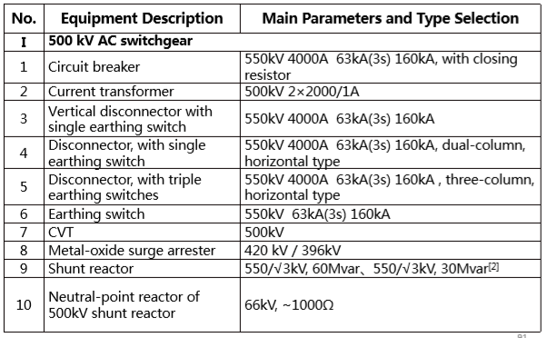

AC Filter
Reactance, Capacitance and Resistance Loss
- There are 16 sub-banks 500kV ACFs and shunt capacitors in total, consisting of 4 banks, with 4 sub-banks each. The bank scheme is 7×SC+3×BP11/BP13+3×HP24/36+3×HP3.
- ACF yard is arranged on the north side of 500kV AC yard.
- Sub banks in each bank are arranged on the same side of the main bus, in a linearly way.
- Equipment inside the fence are connected to the main bus through sub-bank breakers.
- The surge arresters/PTs/earthling switches are arranged under the gantry of main bus.
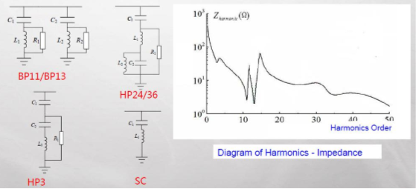
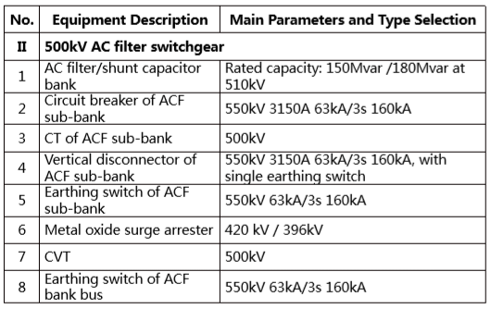

AC Station Control
- Sequence Control Function of Converter Transformer switch
- AC Filter Bank Switch Control
- AC Bus/ Branch Control
- Interlocking of AC switchyard (through DFU420)
- AC switchyard analogs (DFU420 measures AC voltages/ currents/ power/ frequency and sends through profibus to AC station control)
- Control and monitoring of auxiliary equipment (pumps)
- Interlocking control of middle circuit breaker

AC Yard
- AIS equipment are used for 500kV AC yard.
- 500kV circuit breakers are arranged in three rows.
- As to the future phase, 8 complete strings and 2 un-complete strings are configured. 6 complete strings and 4 un-complete strings are built in current phase. Except for the Jamshoro 1 goes out to the north, all the others lines go out to the south.
- 2 groups of converter transformers are connected to AC 500kV strings through overhead lines from north side respectively.
- Four ACF banks are connected to AC 500kV strings through overhead lines from north side respectively.
- 2 sets step-down transformers are directly connected to the 500kV buses through jumper wires respectively. Suspended tubular buses are adopted as 500kV bus. The bus voltage transformers and earthling switches are arranged under the gantry.
- 3/2 circuit breaker connection mode is used for 500kV AC yard.

Auxiliary Equipment and 132kV Power
- Three power supply lines are provided. One power supply line is connected from the outside and the other two are connected from 35kV station transformers in the station.
- AIS equipment is used.
- The external power supply of converter station is tapping via overhead lines from 132kV transmission line nearby.
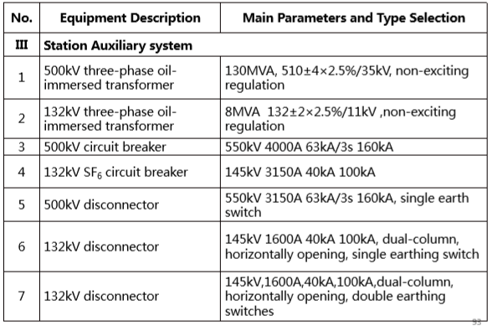
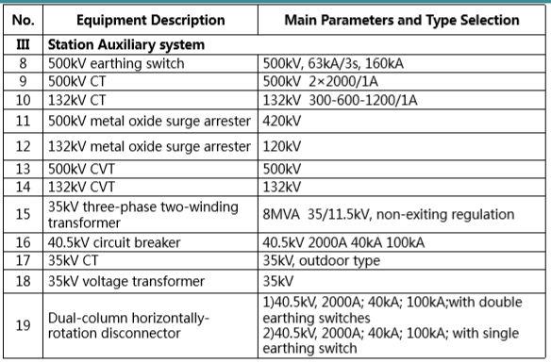

B

Back Metering

Bipolar DC Transmission
Metal Conductor is used for sending and receiving circuit.

Bipole Protection
- Neutral Bus differential
- Station/ Backup Station Ground overcurrent
- NBGS
- GRTS
- MRTB
- Metallic return conductor ground fault
- Metallic return conductor transverse differential
- Metallic return conductor longitudinal differential
- Electrode Line Unbalance
- Electrode Line overload

BOT
Build Operate Transfer

BOOT
Build Operate Own Transfer

Bridge Rectifier
With Commutation overlap and ignition delay
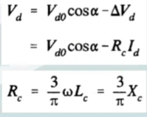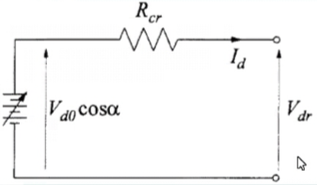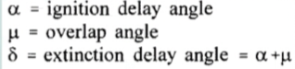
Rectifier Control Modes
- Current Controller
- CIA
- α Control
- Constant DC Current Control
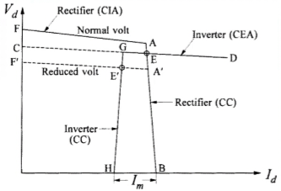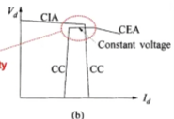

Bridge Inverter
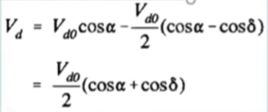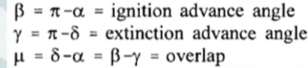
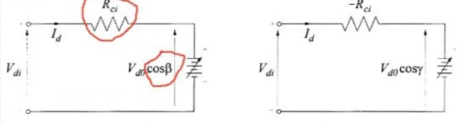
Inverter Control Modes
- Current Controller
- Constant Extinction Angle (CEA)
- Constant DC Voltage Control Mode
- β Control

C

CAN

CCC
Capacitor Commutated Converter

CET
China Electric Power Equipment and Technology Co. Ltd.

CCME
China Chamber of Commerce for Import and Export of Machinery and Electronic Products

CHINCA
China International Contractor Association

Common Cathode Group

Common Anode Group

Commutation Overlap
𝜇

Converter Transformer

Converter Valve
Thyristor, Valve Reactor, DC equalizing resistance, damping capacitance and resistance, steep wave equalizing capacitance, triggering and monitoring equipment. 3 phase short circuit current 36kA.
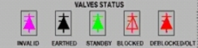
Valve Status:
- Invalid
- Earthed
- Standby
- Blocked
- Deblocked

Converter Valve Control
- Sequence Control (Trip, Block, Deblock, Line Fault recovery)
- Converter Transformer Control (Tap changer, cooling)
- Switch Control (Transformer switch, Earthing switch)
- Extinction Angle Forecast
- Firing Angle limit
- Closed Loop Controller (Current, Voltage, Extinction angle)
- Firing Pulse Control (Generation, Ignition)
- Protective Monitoring (AC Voltage Magnitude and Angle, OLT, impulse loss)

Converter Valve Protection
- Short Circuit
- Commutation Failure
- Overcurrent
- Differential
- Zero Sequence overvoltage

Current Transformer
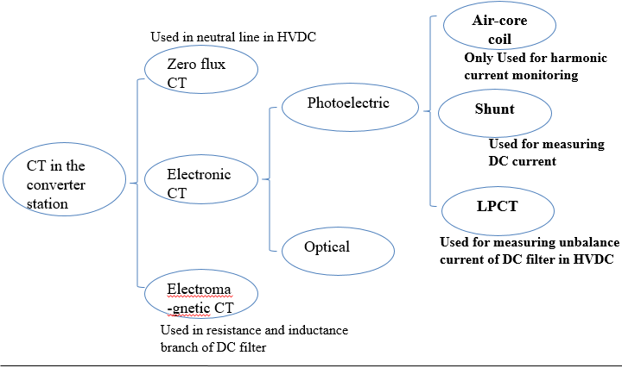

D

Data Logger

DC Equipment
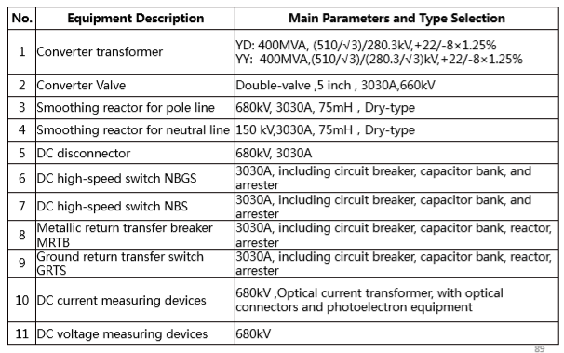
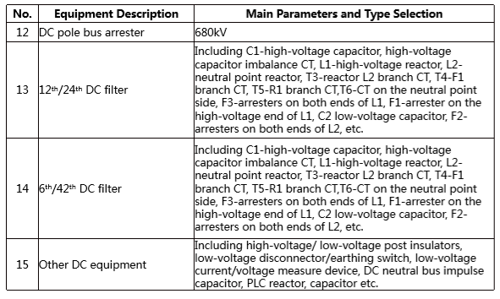

DC Filter
Reactance, Resistance and Capacitance Loss
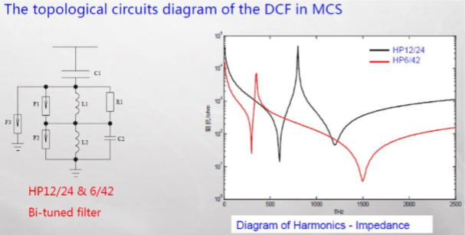
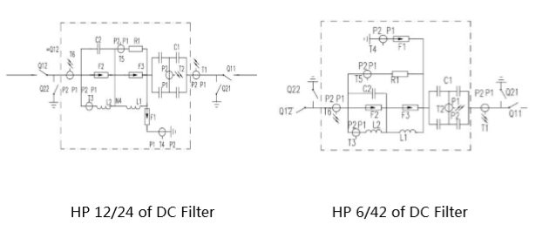

DC Filter Protection
- Resistor/ Reactor overload
- Differential
- HV capacitor unbalance
- Detuning

DC Line Loss
Corona Loss and Insulator Leakage Loss. Pc=U_d1.I_d1+ U_d2.I_d2. Ohmic Loss Id*Id*Rd. 5-7% losses.

DC Line Protection
- Travelling Wave
- Derivative
- Longitudinal differential
- Undervoltage

DC Yard
- DC yard equipment are arranged outdoor and symmetric by 2 poles.
- DC pole line equipment are arranged on both sides, DC neutral line equipment are arranged in the center of DC yard, and 2 DC filter banks are arranged between them on each pole.
- Smoothing reactors are arranged separately, 2 for DC pole line and 3 for DC neutral line on each pole.
- The DC pole bus are brought out from the valve halls by bare conductor via post insulators, and the neutral bus is bought out also by bare conductor.

Deionization Tank

DFU420
Local Measurement and Control Unit

E

Earth Electrode System

EPC
Engineering Procurement and Construction

ENR
Engineering News-Record

Equipment Level

F

FACTS
Flexible AC Transmission System

G

GRTS

H

HVDC
High Voltage DC Transmission
- (Point to Point,
- Low Right of Way/ Transmission Corridor 60% T/L,
- Low Radio Interference,
- Low Losses,
- Large Power Capacity,
- High Tariff,
- No grid connection requirement in middle,
- System stable in frequency and power arc angle oscillations,
- no leakage capacitive currents to ground,
- Limit short circuit current, N
- o need for synchronization,
- Flexible/ Light DC Transmission
- Only two conductors needed.
- Expensive Converter Station,
- Converter Station consumes a lot of Reactive Power,
- Large Filter Devices are needed,
- Converter has little overload capability,
- inefficient DC circuit breakers,
- ground/sea electrodes face corrosion,
- Losses in Converter Transformer, Valves, Smoothing reactors, AC filters etc.
- Equivalent distance of 640-960 km, 5-7% line losses, 1% converter station losses).
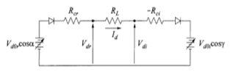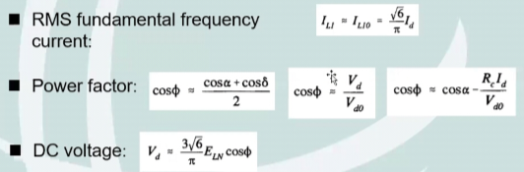
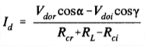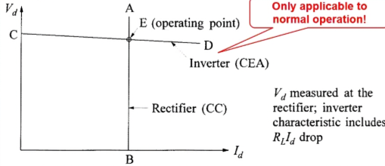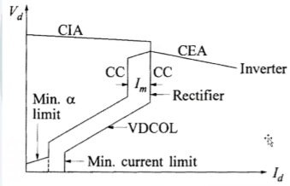
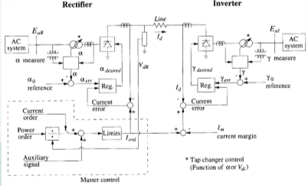
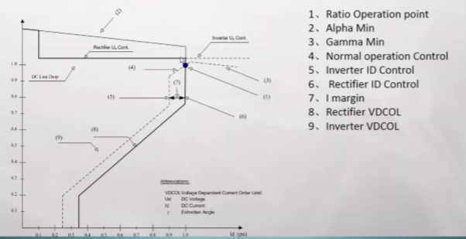
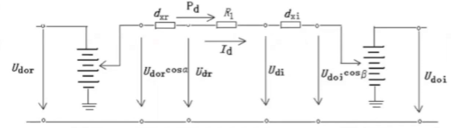
High (>3 or >5) Effective short circuit ratio ensures voltage stability during dynamic overvoltages/ instability/ flicker or harmonic resonance)
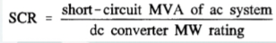

HVDC Link
- Monopolar
- Bipolar
- Homopolar

HVDC Operation Modes
- Pole 1 earth loop mode
- Pole 2 earth loop mode
- Pole 1 metallic return mode
- Pole 2 metallic return mode
- Pole 1 open line test, Pole 2 ground return
- Pole 2 open line test, Pole 1 ground return
- Pole 1 open line test, Pole 2 disconnected
- Pole 2 open line test, Pole 1 disconnected
- Bipolar Current symmetry
- Bipolar Current asymmetry

HVDC Control/ DC Station Control
- Mode Stabalization (Automatic/ Manual Mode for DC switching. Interstation coordination. Software Interlocking of switchgear ᴧ-AND, Ѵ-OR, $\underline{A}$-disconnector open, A-disconnector closed)
- DC Filter Control (Connect/ Isolate, check back supervision, Automatic/ manual driving, mode selection, NB Earthing switch, NB disconnector, DC Line Earthing switch, DC Line disconnector)
- Master/ slave selection
- Bipole DC Power Control (Automatic/ Manual Control, Direction Control, Power ramp rate, Power Modulation POAC (Power order determined through system research, run up and run back, Power Limit, Frequency Limit, Subsynchronous Oscillation Control)
- Auxiliary Reactive Power Control (QPC (Extinction angle change sent to valve bank controller and tap changer), Gamma kick (Temporarily change extinction angle to reduce transient overvoltage when connecting/disconnecting filters))
- Reactive Power Control (RPC) (Limit overvoltages and reactive power exchange with AC system).
- Operation Mode Control (Bipole Power, Monopole Power, Monopole Current Control)
- DC Current Control (Current order/ error PI control balance (Maximum 2% rated current change at rectifier side), margin, coordination, limit, Voltage Dependent Current Order Limit (VDCOL) Control)
- DC Voltage Control (Voltage order, drop, calculation Control, Tap Changer Control)
- Switching Control (Master/ Slave Station and System Level Control, Firing Angle Limits)
- Interfaces (Analogue input (ESP), Binary input/ output (EDI), LAN (to pole control, AC station control, HMI), Fieldbus (to DFU420), IFC (to pole control), TDM, 60044-8 (to station stability device)).

Hot Standby Losses
No Load Losses

I

IEC
International Electrotechnical Commission

IEC 60044-8 bus

Ignition Delay
α

IoT
Internet of Things

J

K

L

LAN

Lahore Converter Station
The receiving converter station of the ±660kV HVDC Project from Matiari to Lahore in Pakistan.
1. DC rated power: 4000MW in bipole;
2. DC rated voltage: ±660kV;
3. DC rated current: 3030A;
4. DC outgoing line : 1 line; DC electrode line : 1 line;
5. AC outgoing line : 6 lines;
6. Converter transformer: 12 sets for work, 2 sets for spare, total 14 sets. The capacity of each converter transformer is 400.4MVA;
7. Smoothing reactor: total inductance of each pole is 300mH, 4 sets for each pole, the inductance of one set is 75mH;
8. DC filter: 1 HP6/42 DCF bank + 1 HP12/24 DCF bank for each pole;
9. AC filter: divided into 4 groups and 16 banks, which are 8 HP12/24 ACF banks (150Mvar) + 8 SC banks (160Mvar). 10. 35kV shunt reactor: 4 banks, 60Mvar each;
11. 510/35kV station transformer: 2 sets, 130MVA each;
12. 132/11kV station transformer: 1 set, 10MVA;
13. 35/11kV station transformer: 2 sets, 8MVA each.

Six Bays
- 1st Bay ACF 1 and Pole 1 Converterer Transformer •
- 2nd Bay ACF 2 and Lahore South 1 •
- 3rd Bay Pole 2 Converterer Transformer and Lahore 1 •
- 4th Bay Lahore North 1 and Lahore North 2 •
- 5th Bay ACF 3 and Lahore 2 •
- 6th Bay ACF 4 and Lahore South 2
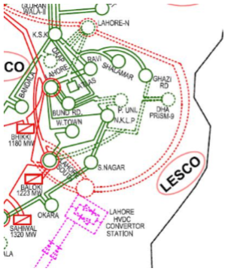

Lightning Arrestor

M

Main Metering

Matiari Converter Station
The sending converter station of the ±660kV HVDC Project from Matiari to Lahore in Pakistan.
- DC rated power: 4000MW in bipole;
- DC rated voltage: ±660kV, there are single-12(6*2) pulses wiring, DC rated current: 3030A;
- DC outgoing line : 1 line, DC electrode line : 1 line;
- 4.Converter transformer: 12 sets for working, 2 sets for spare, total 14 sets. The capacity of each converter transformer is 400.4MVA;
- Smoothing reactor: 4 sets for each pole, the inductance of one set is 75mH, and one fore spare;
- DC filter: 1 HP6/42 DCF bank + 1 HP12/24 DCF bank for each pole;
- AC outgoing line : 12 lines for future phase with 7 lots line HV reactors, 10 lines for current phase with 5 lots line HV reactors. One HV bus reactor is configured. The capacity of line HV reactor is 90Mvar per each, and the bus reactor is 180Mvar.
- The long-term targets for Matiari converter station include 12 AC 500 kV outgoing lines, 4 banks of AC filters (hereinafter referred to as "ACF") and 2 converter transformer groups. There are 18 elements in total, which form 8 complete strings and 2 incomplete strings. At present, Matiari converter station include 10 AC 500 kV outgoing lines, 4 banks of ACF and 2 converter transformers. There are 16 elements in total, which form 6 complete strings and 4 incomplete strings. 5 outgoing lines will be equipped with high-voltage reactors. Otherwise， one of the buses will be connected with a HV Reactor.
10 Bays
- 1st Bay ACF 1 and Pole 2 Converterer Transformer •
- 2nd Bay ACF 2 and SECL 1 •
- 3rd Bay Pole 1 Converterer Transformer and SECL 2 •
- 4th Bay TEL Power Plant •
- 5th Bay Port Qasim 1 and THAL NOVA Power Plant •
- 6th Bay ACF 3 and Port Qasim 2 •
- 7th Bay ACF 4 and Spare 1 •
- 8th Bay Jamshoro 1 and Spare 2 •
- 9th Bay Jamshoro 2 •
- 10th Bay Moro and Dadu New
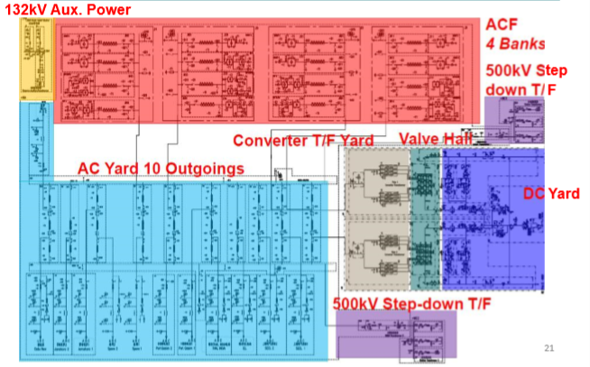
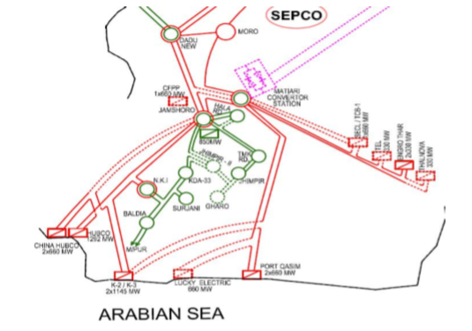

Monopole DC Transmission
Transmission Line has only one metal conductor. Ground or sea water is used as the return circuit.

Mercury Arc Valve
High Fault Rate of Reverse Arc, Low Reliability

MRTB

N

NBS

NBGS

O

OLT
Manual/ Automatic Open Line Test to test insulation capacity of main equipment

OWS
Operator Work Station

P

Panels

HCM3000 Device | EPU20B Panel
HCM3000 Device | SR10D Rack
HCM3000 Device | ENT10B Panel
HCM3000 Device | ESM10B Panel
HCM3000 Device | ITM10C Panel
HCM3000 Device | IFC20A Panel
HCM3000 Device | EFM20A Panel
HCM3000 Device | EVI11A Panel
HCM3000 Device | EVC10A Panel
HCM3000 Device | EDI10B Panel
HCM3000 Device | ECM10A Panel
HCM3000 Device | EOT11C Panel
HCM3000 Device | ESP10C Panel
HCM3000 Device | ETS11 Panel
HCM3000 Device | BEM10 Panel
DFV100 Device | TCU10
DFV100 Device | TVI10
DFV100 Device | DDI10
DFV100 Device | DDO10
HPL100 Device | XS931/3A
HPL100 Device | EPLM20
HPL100 Device | EPLI10
HPL100 Device | EPLR10
DFU410A Device | TAC10
DFU410A Device | TAB10
DFU410A Device | TVC10A
DFU410A Device | TVM10A
DFU410A Device | TVB10B
DFU410A Device | TCN11A
DFU420 Device
DFM411 Device | XAIM11
DFM411 Device | XDIM10
DFM411 Device | XDPM11
DFM411 Device | XPSU10
DFM411 Device | XOIM10
DFM411 Device | XOTM10
DFM411 Device | XPFM11

PCS-9250-EACD DC electronic Current Transformer
3030.3 A
- (1)Primary sensor: Low-Power CT (LPCT) is used to transduce AC current.
- (2) Resistor box: it functions as signal distribution, converts one analog signal to multiple signal outputs. It is equivalent to a high power, high temperature resistance, low temperature coefficient, precise, and low value resistor. The rated output of the shunt is about 75mv, for 3030.3A rated primary current, the shunt resistance is designed to be 25uΩ. The shunt is made of Manganese-Copper alloy, and it is designed as “symmetric squirrel-cage structure” to realize good heat dissipation and anti-interference.
- (3) Remote terminal unit: also called primary converter, it is located at high-voltage side and used for data acquisition, multiple RTUs can be configured in ECT. Receiving the analog signal output from the resistance box, after filtering, sampling, electro-optical conversion, etc., it gives an output of serial digital optical signal. Located at high voltage side, its power supply is provided by the merging unit through the laser light. An optical fiber receiving connector(FC type) is used to receive laser, and an optical fiber transmitting connector(ST type) is used to send digital signals. low-power design and dual sampling.
- (4) Optical fiber insulator: it is a solid composite insulator with embedded optical fibers. When installed in suspension type, using suspended optical fiber insulator. And also could be support type. The insulator is embedded with 24 or 32 multi-mode optical fibers, and the spared optical fiber core is not less than 100%. The insulation structure is simple and reliable, mainly bearing its own weight and wind load for suspension type.
- (5) Merging unit: placed in the control room. It is used for providing laser energy to power RTUs, receiving and processing the data from the RTUs and transmitting them to the control & protection system according to IEC 60044-8 protocol. Self-monitoring function, monitoring parameters: laser driving current, receiving data level, RTU temperature, laser temperature, parity check error times.
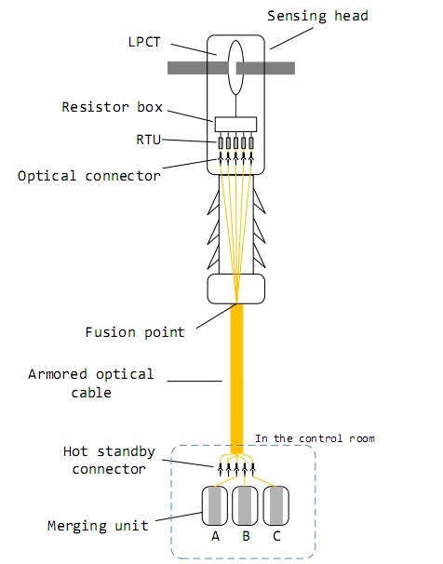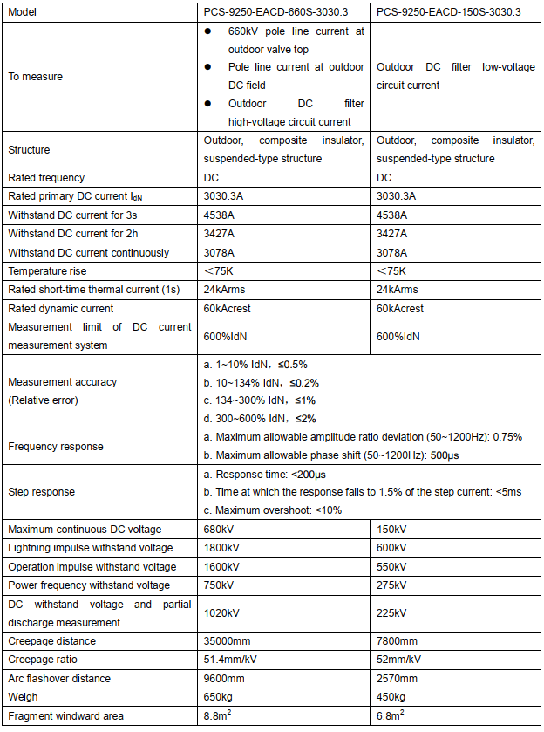

PCS-9250-EAVD DC electronic Voltage Transformer
660kV
- (1)DC voltage divider: it adopts resistor voltage divider with capacitor compensation, the resistors and capacitors are located in a silicone rubber composite-insulation cylinder, and the inside is filled with SF6 gas.
- (2) PCS-9559 IO unit: it is used for analog quantity isolation, installed in cabinet at the control room. The device is connected with the DC voltage divider through four-core double-layer shielded cable. Each DC voltage divider is equipped with three sets of PCS-9559 IO unit. The rated output signal of PCS-9559 is 5V The main function of PCS-9559 IO unit is to divide and isolate the output signal of DC voltage divider. Each PCS-9559 is equipped with one resistor voltage divider (NR1478) and two isolation output modules (NR1411). Each DC voltage divider must be equipped with three sets of PCS-9559 IO units. The rated secondary output of the device is ±5V.
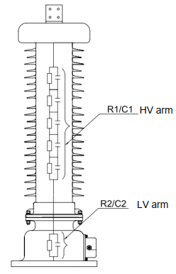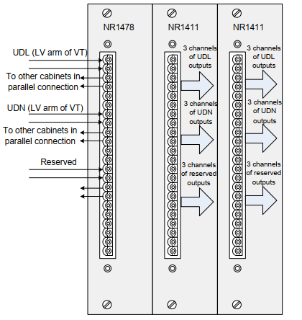

PPP
Private Participation in Infrastructure Projects

PMLTC
Pak Matiari-Lahore Transmission Company Pvt. Ltd. responsible for 886 km, +/- 660 kV, 3030 A, 4 GW, 1971 Self-Supported, Double-Circuit Towers, 388 (242+146) Electrode Line Towers, Quad-bundle 4*1250 mm² conductors (Matiari-Sukkur 214km ACAAR 4*JL1/LH1-800/550) + (Sukkur-Lahore 664km ACSR 4*JL1/G3A-1250/70), 24 Fiber OPGW-120 * 2 Shield Earth Wires, Substations (TEL 330MW, ENGRO THAR 2X330MW, THAL NOVA 330MW, SECL/TCB-1 660MW (+660MW), SIDDIQUE SONS 330MW, PORT QASIM 2X660MW, LUCKY ELCTRIC 660MW. K2 NUCLEAR POWER 1100MW, JAMSHORO, DADU NEW, MORO) HVDC Transmission Project (1 Dec 2018-2043 Commercial Operation Date 1 Mar 2021).

POAC
Power Order Calculator

Pole Control
- Master/ slave selection
- Sequence Control (Start, Stop, OLT)
- DC Line Fault Recovery
- Power Control
- Power Direction Control
- Power Modulation (run up and run back, Frequency Limit, Subsynchronous Oscillation Control)
- Converter Status Control (Current, Voltage, Angle)
- Tap Changer Control (Position/ running/ faulty signal, control (No load, Angle, Ud, gamma controls))
- Operation Mode Control (Bipole Power, Monopole Power, Monopole Current Control)
- DC Current Control (Manual/ Auomatic Control, Current order (single pole mode, bipole mode, pole synchronous mode, communication failure mode), current balance, current margin compensation (maintain pole current order), coordination, limit (based on equipment overload (2s, 2h, continuous)/ filters/ power limit/ protection request/ blocking/ deblocking/ VDCOL), VDCOL Control)
- DC Voltage Control (Voltage order, drop, calculation Control during different modes and fault recovery)
- Extinction Angle Control
- Firing Angle Control
- Selection of Controller
- Auxiliary Reactive Power Control (QPC, Gamma kick)
- Switch Control and Monitoring
- Protective Monitoring (X/ Y/ Z block (Force retard, Block firing pulses, Trigger bypass, Trip circuit breaker), large angle monitoring, fast shut down, AC voltage limit)
- Commutation Failure Protection (zero sequence voltage criterion, constant extinction area criterion)

Pole Protection
- DC overvoltage
- DC undervoltage
- 50 Hz/ 100 Hz
- Pole busbar differential
- Neutral busbar differential
- Pole differential
- Electrode Line Open
- Ac/ DC Line touch
- NBS
- Neutral bus capacitor protection

Protection Zones
- Converter
- DC pole bus
- DC neutral bus
- Line
- Bipole (NBS, NBGS, GRTS, MRTB)
- DC Filter

PZ61/800Ah-232-200A/220V DC Power Panel
AC Distribution Unit, HF rectifier Module, insulation test module, DC Feeder unit, centralized monitoring module.
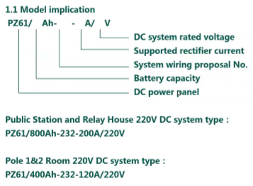

Q

R

Redundancy
2 out of 3 principle

MiCOM Relays
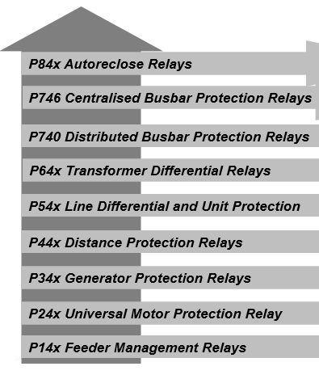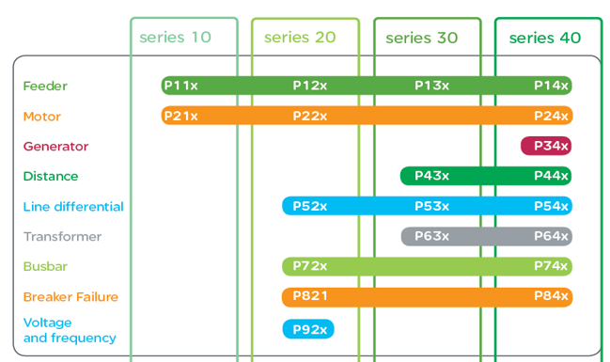

RPC
Reactive Power Control
- Overvoltage Control
- AbsMinFilter
- U_Maximum/ U_Minimum
- Q_Maximum
- MinFilter
- Q_Control/ U_Control

Redundant Cooling

Reverse Osmosis Unit

S

SGCC
State Grid Corporation of China

Shunt Capacitor
Harmonic Loss and power frequency loss

Shunt Reactor

Smoothing Reactor
DC loss and harmonic loss

Station Level

SVC
Static VAR Compensator

System Server

T

U

UHVDC
Ultra High Voltage DC

UPS
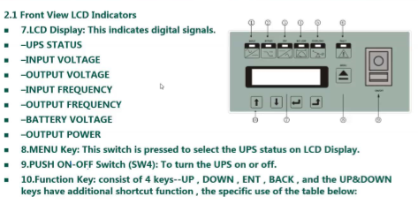
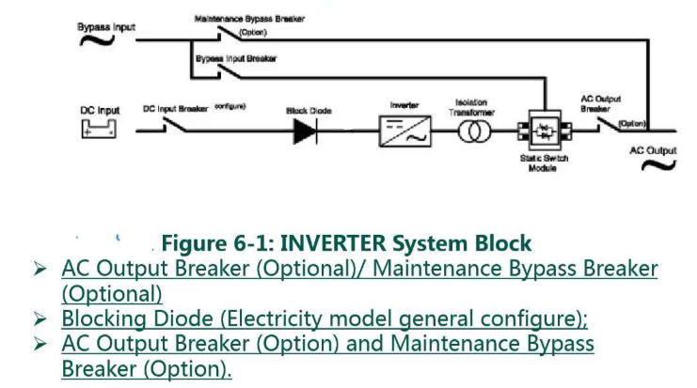
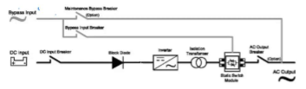Normal Mode
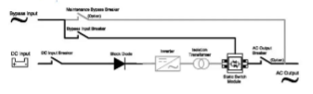Static Bypass Mode
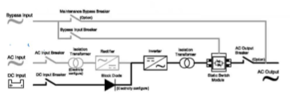Backup Mode
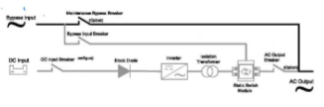Maintenance Bypass Mode

V

Valve Hall
- Twelve converter transformers are arranged in a linear way in the west of the valve halls, and every six sets corresponds to the one pole.
- The bushings of converter transformer on valve side are inserted into the valve hall and connected to valves after Y/Δ being connected. Converter transformers are separated by firewalls.
- The towers of junction bus are located on the north and south sides of the fire walls, making the junction bus above the converter transformers.
- The incoming line of converter transformers is brought from 500kV AC switchyard.
- The junction bus is hanged in a higher position whereas the incoming line crossover beneath it.
- The surge arresters of valve-side of converter transformer, the RI capacitors, the surge arresters, the CTs of the neutral point, and the post insulators are all located on the top of the fire walls.

Voltage Measuring System

W

X

Y

Z

Zero Flux Current Transformer
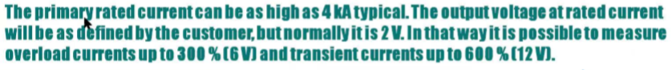
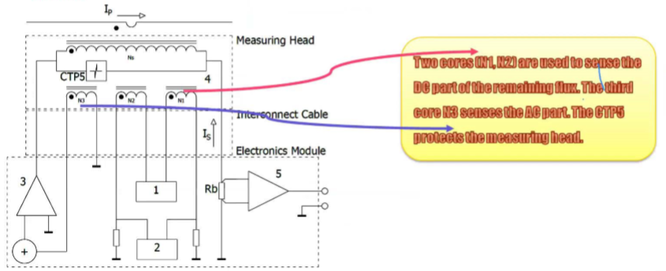
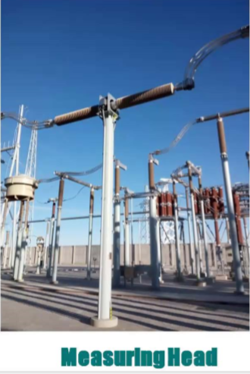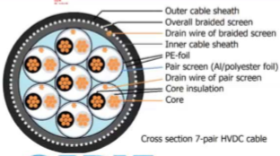

ZZDFPZ-400400/500– 660/330 Converter Transformer
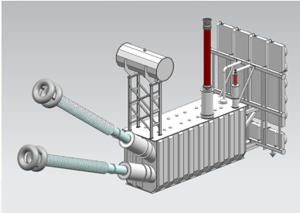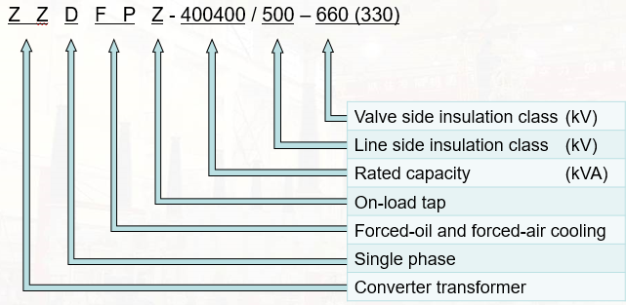
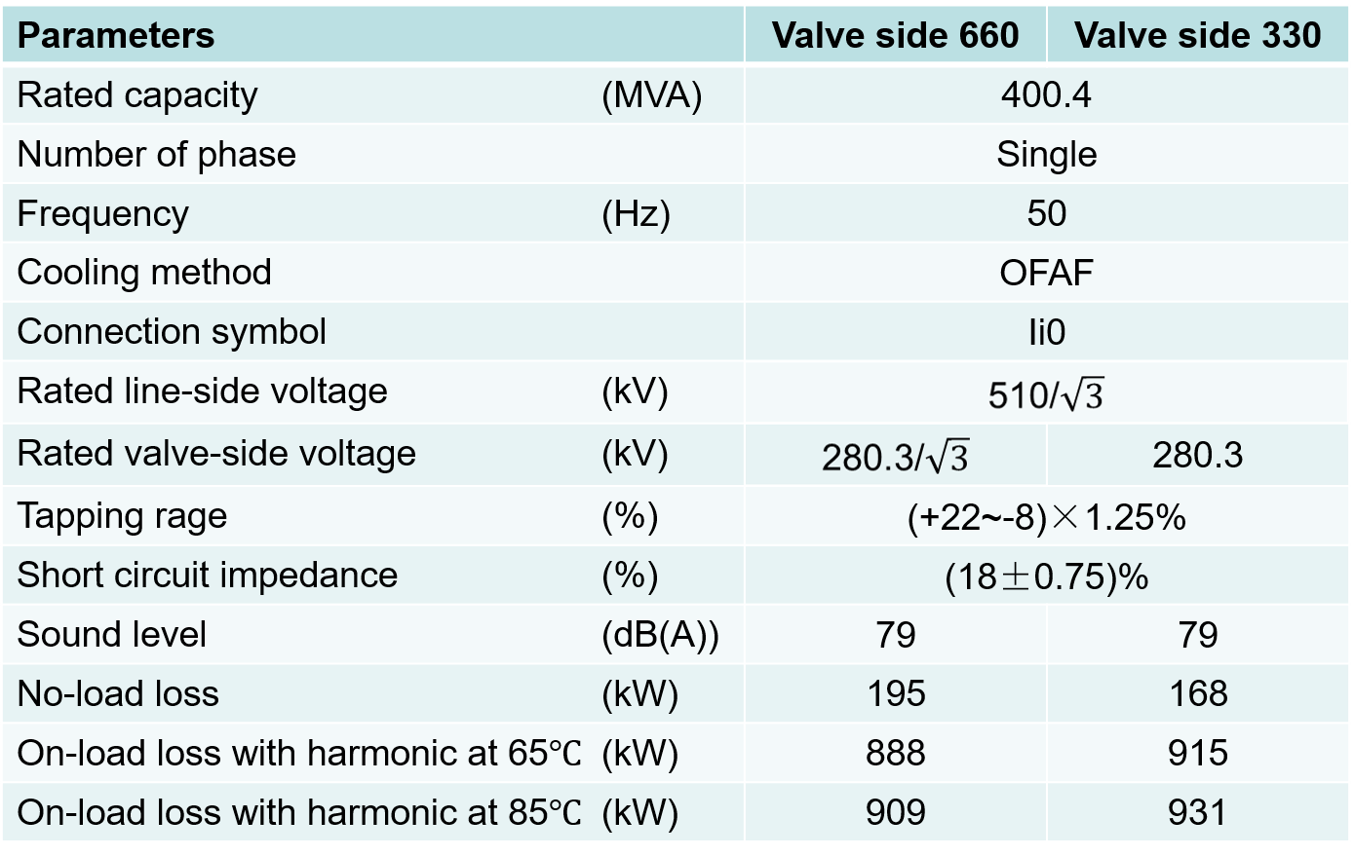

Insulation Level
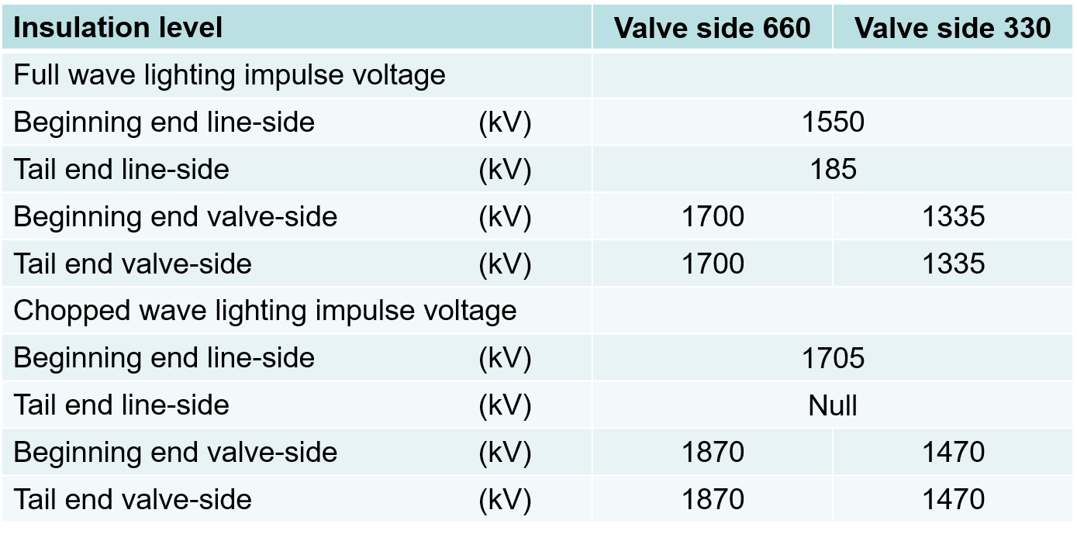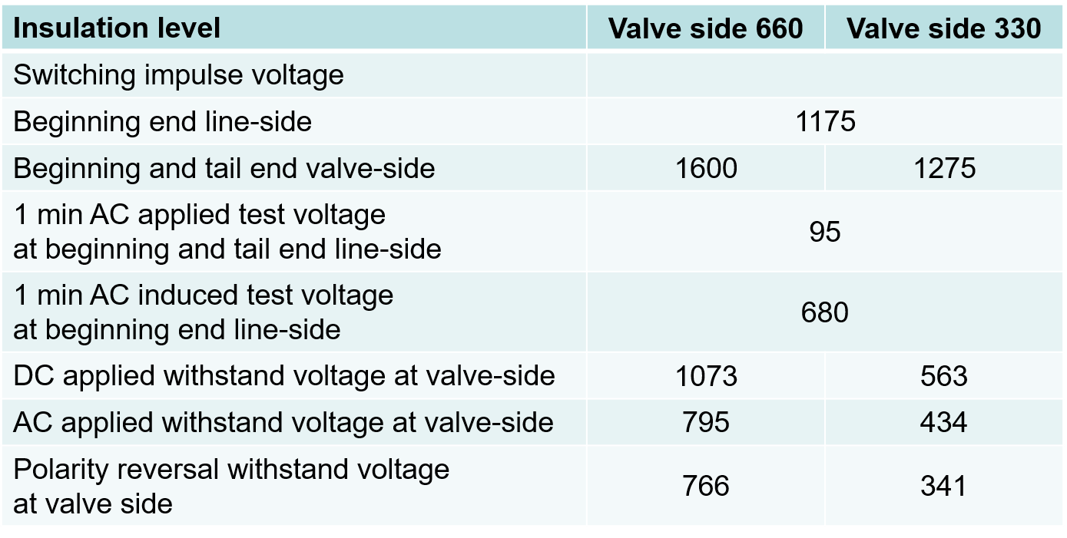
Transformer Oil
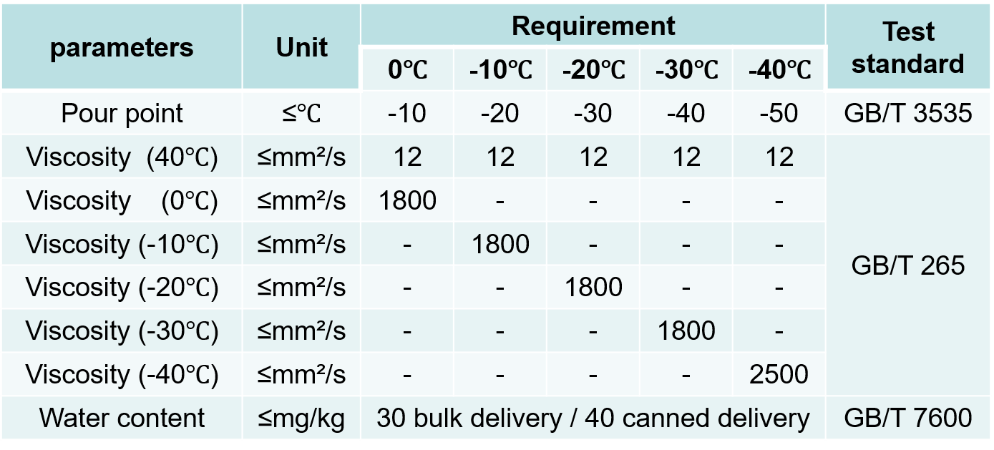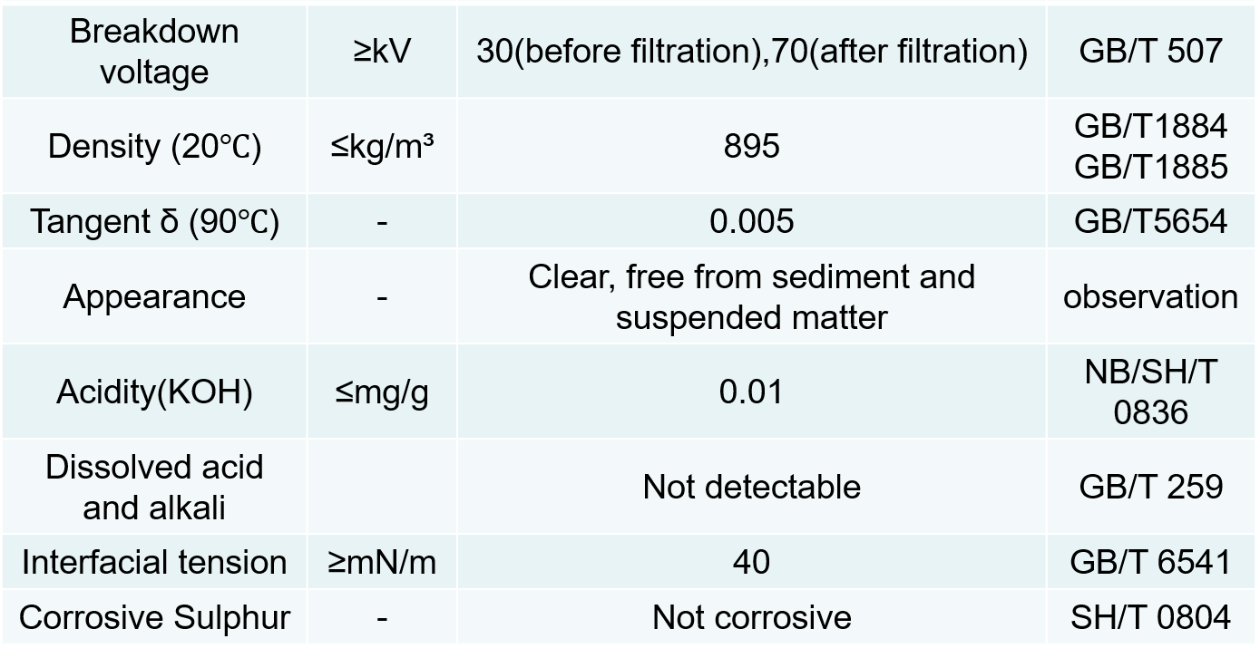
Maintenance
